Compound Units
# Source: AI Source: Provided by: [Data Path: Persons Table -> ID Column: 1, Name_En Column: Motasem Essam] -> From: [ChatGPT] on [7/17/2026]
Compound Units are units formed by combining two or more basic or derived units using multiplication or division to describe relationships between different physical quantities. They are used to measure quantities that depend on more than one fundamental measurement, such as speed, acceleration, force, pressure, density, and power.
Compound units are essential in science, engineering, mathematics, physics, chemistry, and everyday applications because many real-world quantities involve multiple dimensions or rates.

Definition
# Source: AI Source: Provided by: [Data Path: Persons Table -> ID Column: 1, Name_En Column: Motasem Essam] -> From: [ChatGPT] on [7/17/2026]
A Compound Unit is a unit of measurement created by multiplying and/or dividing two or more units to represent a derived physical quantity.

Purpose
# Source: AI Source: Provided by: [Data Path: Persons Table -> ID Column: 1, Name_En Column: Motasem Essam] -> From: [ChatGPT] on [7/17/2026]
Compound units are used to:
- Measure derived physical quantities.
- Express relationships between different measurements.
- Describe rates (such as speed).
- Support scientific and engineering calculations.
- Standardize complex measurements.

Characteristics
# Source: AI Source: Provided by: [Data Path: Persons Table -> ID Column: 1, Name_En Column: Motasem Essam] -> From: [ChatGPT] on [7/17/2026]
Compound units:
- Combine two or more units.
- Use multiplication (·) or division (/).
- Represent derived quantities.
- May include powers such as squares (²) or cubes (³).
- Are commonly expressed using SI units.

Types of Compound Units

1. Units Formed by Division
# Source: AI Source: Provided by: [Data Path: Persons Table -> ID Column: 1, Name_En Column: Motasem Essam] -> From: [ChatGPT] on [7/17/2026]
These describe rates or relationships between different quantities.
Examples:
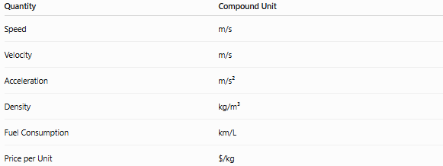
Quantity | Compound Unit
Speed | m/s
Velocity | m/s
Acceleration | m/s²
Density | kg/m³
Fuel Consumption | km/L
Price per Unit | $/kg

2. Units Formed by Multiplication
# Source: AI Source: Provided by: [Data Path: Persons Table -> ID Column: 1, Name_En Column: Motasem Essam] -> From: [ChatGPT] on [7/17/2026]
These describe products of quantities.
Examples:

Quantity | Compound Unit
Area | m²
Volume | m³
Torque | N·m
Moment | N·m

Common Compound Units

Speed
# Source: AI Source: Provided by: [Data Path: Persons Table -> ID Column: 1, Name_En Column: Motasem Essam] -> From: [ChatGPT] on [7/17/2026]
Measures distance traveled per unit of time.
Unit:
m/s
Example:
A car travels at 20 m/s.

Velocity
# Source: AI Source: Provided by: [Data Path: Persons Table -> ID Column: 1, Name_En Column: Motasem Essam] -> From: [ChatGPT] on [7/17/2026]
Measures displacement per unit of time.
Unit:
m/s
Example:
15 m/s east

Acceleration
# Source: AI Source: Provided by: [Data Path: Persons Table -> ID Column: 1, Name_En Column: Motasem Essam] -> From: [ChatGPT] on [7/17/2026]
Measures change in velocity per unit of time.
Unit:
m/s²
Example:
9.81 m/s²

Force
# Source: AI Source: Provided by: [Data Path: Persons Table -> ID Column: 1, Name_En Column: Motasem Essam] -> From: [ChatGPT] on [7/17/2026]
Measures the interaction that changes motion.
SI Unit:
newton (N)
Equivalent compound unit:
$$1 N=1 kg⋅m/s^{2}$$

Pressure
# Source: AI Source: Provided by: [Data Path: Persons Table -> ID Column: 1, Name_En Column: Motasem Essam] -> From: [ChatGPT] on [7/17/2026]
Measures force distributed over an area.
SI Unit:
pascal (Pa)
Equivalent compound unit:
$$1 Pa=1 N/m^{2}$$

Density
# Source: AI Source: Provided by: [Data Path: Persons Table -> ID Column: 1, Name_En Column: Motasem Essam] -> From: [ChatGPT] on [7/17/2026]
Measures mass per unit volume.
Unit:
kg/m³
Example:
Water:
1000 kg/m³

Flow Rate
# Source: AI Source: Provided by: [Data Path: Persons Table -> ID Column: 1, Name_En Column: Motasem Essam] -> From: [ChatGPT] on [7/17/2026]
Measures volume passing per unit time.
Units:
- m³/s
- L/min

Power
# Source: AI Source: Provided by: [Data Path: Persons Table -> ID Column: 1, Name_En Column: Motasem Essam] -> From: [ChatGPT] on [7/107/2026]
Measures energy transferred per unit time.
SI Unit:
watt (W)
Equivalent compound unit:
$$1 W=1 J/s$$

Energy
# Source: AI Source: Provided by: [Data Path: Persons Table -> ID Column: 1, Name_En Column: Motasem Essam] -> From: [ChatGPT] on [7/17/2026]
Measures work done.
SI Unit:
joule (J)
Equivalent compound unit:
$$1 J=1 N⋅m$$

Examples
# Source: AI Source: Provided by: [Data Path: Persons Table -> ID Column: 1, Name_En Column: Motasem Essam] -> From: [ChatGPT] on [7/17/2026]
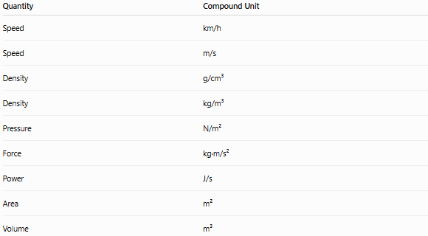
Quantity | Compound Unit
Speed | km/h
Speed | m/s
Density | g/cm³
Density | kg/m³
Pressure | N/m²
Force | kg·m/s²
Power | J/s
Area | m²
Volume | m³

SI Derived Units as Compound Units
# Source: AI Source: Provided by: [Data Path: Persons Table -> ID Column: 1, Name_En Column: Motasem Essam] -> From: [ChatGPT] on [7/17/2026]
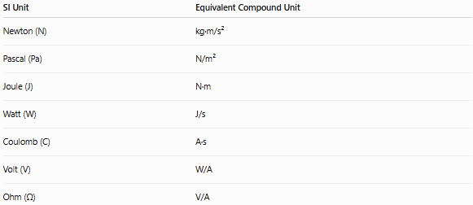
SI Unit | Equivalent Compound Unit
Newton (N) | kg·m/s²
Pascal (Pa) | N/m²
Joule (J) | N·m
Watt (W) | J/s
Coulomb (C) | A·s
Volt (V) | W/A
Ohm (Ω) | V/A

Applications
# Source: AI Source: Provided by: [Data Path: Persons Table -> ID Column: 1, Name_En Column: Motasem Essam] -> From: [ChatGPT] on [7/17/2026]
Compound units are used in:
- Physics
- Engineering
- Chemistry
- Medicine
- Meteorology
- Manufacturing
- Transportation
- Construction
- Economics (e.g., price per unit)
- Everyday measurements

Advantages
# Source: AI Source: Provided by: [Data Path: Persons Table -> ID Column: 1, Name_En Column: Motasem Essam] -> From: [ChatGPT] on [7/17/2026]
Compound units:
- Describe complex physical relationships.
- Improve measurement accuracy.
- Support mathematical modeling.
- Standardize scientific calculations.
- Simplify communication of derived quantities.

Common Mistakes
# Source: AI Source: Provided by: [Data Path: Persons Table -> ID Column: 1, Name_En Column: Motasem Essam] -> From: [ChatGPT] on [7/17/2026]
- Confusing m/s with m/s².
- Forgetting parentheses when writing divided units.
- Mixing incompatible units (e.g., kg/m instead of kg/m³ for density).
- Omitting exponents in area (m²) or volume (m³).
- Treating derived SI units (such as N or Pa) as unrelated to their compound-unit definitions.

Key Points
# Source: AI Source: Provided by: [Data Path: Persons Table -> ID Column: 1, Name_En Column: Motasem Essam] -> From: [ChatGPT] on [7/17/2026]
- Compound Units combine multiple units using multiplication or division.
- They are used to measure derived quantities.
- Common examples include:
  - m/s (speed)
  - kg/m³ (density)
  - N/m² (pressure)
  - J/s (power)
- Many SI derived units can be written as equivalent compound units.
- Compound units are fundamental in science, engineering, and mathematics.

Conclusion
# Source: AI Source: Provided by: [Data Path: Persons Table -> ID Column: 1, Name_En Column: Motasem Essam] -> From: [ChatGPT] on [7/17/2026]
Compound Units are measurement units formed by combining two or more units through multiplication and/or division to represent derived physical quantities. They are used to describe relationships such as distance per time (speed), mass per volume (density), force per area (pressure), and energy per time (power). Compound units provide a standardized and precise way to express complex measurements, making them indispensable in science, engineering, manufacturing, medicine, economics, and everyday problem-solving.

